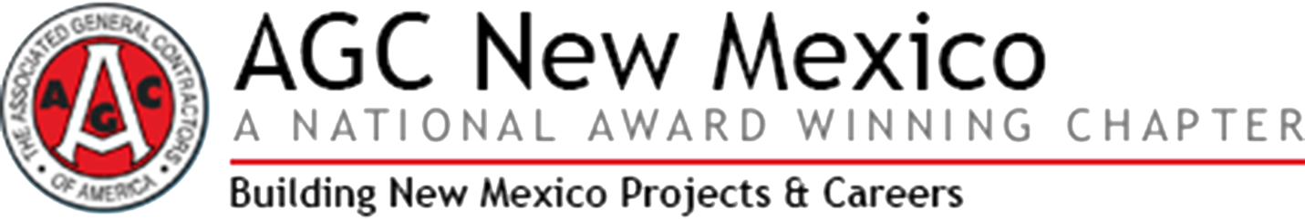

THIRTIETH ANNUAL

National AGC Safety Awards

TO: Member Executives
Member Safety Professionals

SUBJECT: 30th Annual National AGC Safety Awards (NASA)

DATE: December 6, 2020

Program Description

Why You Should Participate: The National AGC Safety Awards (NASA) program has been an ongoing effort since 1991 to offer AGC members an opportunity to evaluate their safety record. Participating members receive a confidential printout to compare their company's safety statistics with similar size and type AGC members both locally and nationally. NASA provides a great opportunity for members with excellent safety records to compete for nationally recognized awards. Additionally, this information can be used to assist in determining if additional accident prevention and loss-control measures are necessary.

Who Can Participate: AGC members with direct-hire, job-site craft labor are eligible to compete in the following categories:

- Building
- Federal & Heavy
- Highway
- Utility Infrastructure
- Associate/Specialty

If members wish to compete in more than one category, you are required to separate your safety statistics and work hours by category.

How the Program Works: This program is similar to the Bureau of Labor Statistics and Occupational Safety and Health Administration (BLS-OSHA) recordkeeping systems. The completed OSHA Form 300A Summary of Work-Related Injuries and Illnesses provides the information needed for participation in the NASA Program.

The data is tabulated to produce total lost workday case incidence rates (excluding restricted workdays). The formula for computing “incidence” is structured to multiply the incidence cases involving days away from work (N) times 200,000. The resulting product is then divided by the work hours of exposure (WH). The formula is the days away case incidence rate.

Days Away, Case Incidence Rate = N x 200,000
WH

WH is the number of work hours for the calendar year 2019 (including office hours). N is the number of days-away-from-work cases, which represents the number of cases resulting in days away from work, but does not include job transfer or restricted activity. N is obtained from the total amount of entries recorded in section (H), total number of cases with days away from work, of the OSHA form 300A.

FORM BELOW
PARTICIPANT FORM – DEADLINE February 7, 2020

Complete your OSHA form 300A “Summary of Work-Related Injuries and Illnesses” for 2019.
Review your OSHA form 300A and note:

- Section (G) “Total number of deaths”;
- Section (H) “Total number of cases with days away from work”;
- Section (I) “Total number of cases with job transfer or restriction”;
- Section (J) “Total number of other recordable cases”; and
- Employment Information “Total hours worked by all employees last year”.

Report your company’s numbers from the OSHA form 300A – section (G), section (H), section (I), section (J) and work hours – to your AGC Chapter contact person, via e-mail, telephone, fax, or mail.

If you would like to compete in more than one division, you are required to separate your safety statistics and work hours accordingly.

Chapter Code and Name: 34B AGC New Mexico
AGC Member ID Number (we will complete if unsure):
Company Name (as it should appear on the award):
Contact Person (Name and Phone Number):
AGC Division/  Construction Type | OSHA Form 300A Data
 | (G) | (H) | (I) | (J) | Total Hours Worked
Building
Highway
Federal & Heavy
Utility Infrastructure
Associate/Specialty

