Company Name ____________________Date________
Topic: “Ladder Safety”

Introduction: Good [morning/afternoon/evening] everyone,

Today, we're going to discuss a crucial topic that is relevant to our daily work - ladder safety. Whether you're a seasoned professional or new to the job, understanding and practicing ladder safety is essential to prevent accidents and ensure a safe working environment.

Why Ladder Safety Matters: Ladders are a common tool used in various industries, but they can pose serious risks if not used properly. Falls from heights, improper ladder placement, and using damaged or defective ladders are some of the common causes of accidents. By following proper ladder safety procedures, we can significantly reduce the risk of injuries.

Key Points for Ladder Safety:
- Choose the Right Ladder:
  - Select a ladder that is appropriate for the task at hand.
  - Ensure the ladder is the right height for the job - avoid standing on the top rungs or overreaching.

- Inspect Your Ladder:
  - Before each use, inspect the ladder for any visible damage or defects.
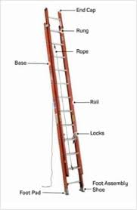
  - Check for loose or missing rungs, split side rails, or any other signs of wear and tear.
  - If you find any issues, tag the ladder as out of service and report it for repair or replacement.

- Set Up on Stable Ground:
  - Place the ladder on a firm, level surface.
  - Use leveling devices or leg extensions if necessary to ensure stability.
  - Never place ladders on uneven or slippery surfaces.

- Maintain Three Points of Contact:
  - When climbing up or down, always maintain three points of contact (two hands and one foot or two feet and one hand).
  - Carry tools in a tool belt or raise and lower them using a hand line, never while climbing.

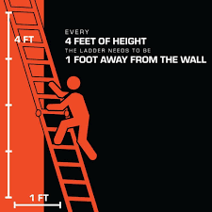
- Use the 4:1 Rule:
  - For every 4 feet of ladder height, move the base 1 foot away from the wall or structure.

- Avoid Overreaching:
  - Never overreach while on a ladder. It's better to climb down and reposition the ladder than risk a fall.

- Limit Time on Ladders:
  - Prolonged use of ladders can lead to fatigue and increase the risk of accidents. Take breaks and rest when needed.

Conclusion: In conclusion, ladder safety is everyone's responsibility. By following these simple guidelines, we can create a safer work environment for ourselves and our colleagues. Always prioritize safety over speed, and if you have any concerns or questions about ladder safety, don't hesitate to ask your supervisor or safety officer.

Remember, it's better to spend a few extra minutes ensuring your safety than dealing with the consequences of an avoidable accident. Stay safe, and let's make sure we all go home in one piece at the end of the day.
Thank you.

Attendee Name | Signature

