*Workforce Development & Community Education*



Performance Report:

Transportation Construction Career Readiness Training Program

June 5 – 23, 2017

Prepared by:

Community Based Education and Workforce Development Division

University of New Mexico, Gallup

Gallup, New Mexico

Prepared for:

New Mexico Department of Transportation

1120 Cerrillos Road

Santa Fe, NM, 87504-1149

August 17, 2017

**Background**

New Mexico offers a unique opportunity to diversify the pool of future transportation workers.

New Mexico has the largest percentage Hispanic population (46%) of any state (National Center for Education Statistics, 2011; NCSL, 2011) as well as the highest percentage of Hispanics (59.9%) among public K-12 students. New Mexico also ranks number one for percentage of Hispanics (42.4%) among public postsecondary students. Moreover, New Mexico has relatively high college completion rates among Hispanics in comparison to other states. (NCSL, 2011)

New Mexico has the second largest percentage Native American population (10%) of any state as well as fourth highest number of Native American residents (193,222). (United States Census Bureau, 2012)

However, there is still an achievement gap in educational outcomes. For example, among New Mexico public school eighth graders in 2015, Hispanics and Native Americans lagged non-Hispanic whites in math basic proficiency by 20% and 30% respectively (57% vs. 47% vs. 77%). (National Center for Education Statistics, 2015)

New Mexico’s unemployment rate was 6.6 percent in May 2017, about 2.4% higher than the national rate. In May 2017, the construction industry posted the second highest growth in the number of jobs in New Mexico, adding 3,200 jobs, and by far the largest percentage gain, 7.5 percent. (NMDWS 2017a) 11.5 percent of the state’s labor force lacked a high school diploma – 2.4 percent higher than the national average in 2017. American Indians faced the greatest challenges in the state labor market. Labor force participation among American Indians was 56.1 percent, the lowest among all races and ethnicities in New Mexico. Unemployment stood at 16 percent in this group. Hispanic unemployment stood at 7.7 percent. (NMDWS 2017b)

**Public-Private Collaboration**

On February 3, 2017, staff from the New Mexico Department of Transportation (NMDOT) and from the New Mexico Building Education Foundation (NMBEF) of the Associated General Contractors of New Mexico (AGCNM) met to discuss possible opportunities for job training programs in the transportation construction industry.

The two organizations identified an alignment of efforts with regard to providing transportation construction education to underrepresented groups in New Mexico. The NMBEF received a Kellogg Foundation grant in 2016 to “improve economic security of low-income individuals in McKinley County, New Mexico, by planning and piloting an industry-driven career education pathway into regional, higher-quality, growth occupations.” According to the Census Bureau, almost 80% of McKinley County residents were American Indian in 2016. (Census Bureau, 2017) NMDOT was seeking partners to implement its OJT/SS grant, which required that NMDOT demonstrate “plans to provide a career path for individuals in underrepresented/disadvantaged groups,” as well as “demonstrate the involvement and collaboration among construction and professional trade associations, contractors, educational institutions (trade schools, public schools, community colleges, and universities), Departments of Labor, Departments of Education, and/or advocacy, non-profit, or veteran organizations.”

The two organizations reached out to the Community Based Education and Workforce Development Division at the University of New Mexico, Gallup (UNM-G) to organize a Transportation Construction Career Readiness Training Program to provide training for 12-14 persons in basic transportation construction skills.

The proposed program received encouragement from representatives of the Navajo tribal government as well as from the Federal Highway Administration. Senior staff in NMDOT’s District Six indicated that the proposed training curriculum aligned well to the needs of that department as well as to private sector transportation construction employers.

In April and May 2017, UNM-G held information sessions to recruit participants for the training program. They also reached out to area high schools to identify graduates who might want to participate in the program. When recruitment was complete, UNM-G had identified 14 participants for the twelve funded slots in case of student attrition. The training program was offered to all 14 participants.

**Transportation Construction Career Readiness Training Program Performance**

The Transportation Construction Career Readiness Training Program was taught at UNM-G in Gallup, New Mexico from June 5 – 23. Thirteen students participated in the course. Three were female. All participants were members of an underrepresented group as defined by OJT/SS guidelines. Twelve participants were American Indian. Twelve participants were unemployed. Twelve participants were either high school graduates or had attained GEDs. The thirteenth is currently in high school. This was a pilot program. (See data chart below for details.)

Thirteen students completed the course. Attendance at each class meeting was good. No student missed more than three class meetings and eight students missed no class meetings.

Participants received training in a range of construction skills such as construction math, use of hand tools and power tools, reading construction drawings, basic rigging, and developing personal employability skills. Additionally, trainees received the basic OSHA 10 hour safety training. The full program scope is provided as Attachment A to this report. More generally, students were provided awareness of the various career opportunities available in transportation and construction, which provided them more choices of possible future careers.  The students tackled the material with enthusiasm.

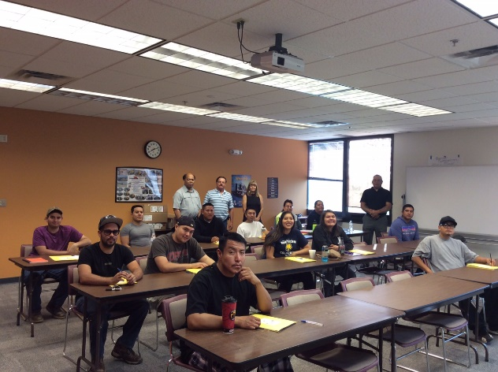 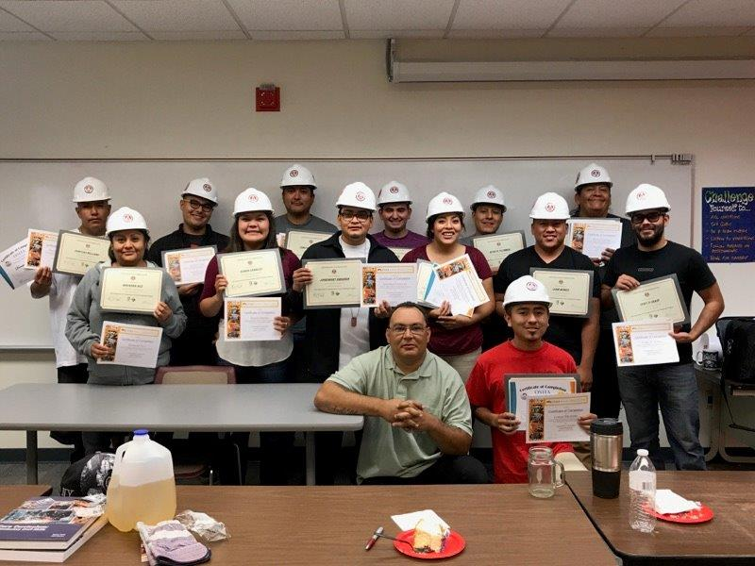

**Outcomes**

All thirteen students completed the training curriculum, completed NCCER assessment, completed OSHA assessment, and received program completion certifications and OSHA 10 cards. Additionally, AGCNM provided assessment for NCCER certification. Four students achieved the requisite 75 score or higher to earn NCCER certification. Seven students scored 70 or higher required to pass the course.

Staff from AGCNM, UNM-G and NMDOT met to discuss the outcomes and next steps. Class attendance appeared to be one factor that affected participant success. Six of the eight students who attended all classes passed the course; five of six students who missed at least one class meeting did not pass the course. The staff evaluation also found that the weakest performance on the NCCER certification exam was on the tools and construction drawings components of the course. The instructors will be encouraged to meet with NCCER examiners prior to any future iteration of this training curriculum to ensure that all critical information is included in the course as well as to consider more effective learning strategies – perhaps greater use of project-based learning over in-class instruction.



Program administrators are currently working to arrange for students to take a three-day refresher course to improve the NCCER certification rate.

At the conclusion of the program, Navajo offered to pay for tribal members in the program to receive further training at UNM-G to attain commercial motor vehicle operator certification. Five students have enrolled in CMV training.

**Recommendations**

*Course Length*. The low rate of passage on the NCCER assessment indicates that a longer curriculum and more targeted course material review may be required. At the end of the program, participants indicated that they would have taken an additional week or more of instruction if it had been offered. Course instructors and program administrators should be asked if 1-3 additional weeks would improve course outcomes.

*Attendance*. UNM-G will ask program participants about barriers to attendance to identify possible opportunities to improve attendance in future program iterations.

*Commercial Driver’s License/Heavy Equipment Operator Training*. A NMDOT Assistant District Engineer who reviewed the Transportation Construction Career Readiness Training Program curriculum indicated that the student employability would be further enhanced if additional training could be provided to qualify the participants for a commercial driver’s license and/or to operate heavy equipment. This perspective aligns with the AGCNM interconnected learning model whereby additional educational components can be implemented to address specific training needs. Navajo Department of Transportation is considering possible funding for program participants who are Navajo members to receive CDL training.

*Protective Gear*. This year, hard hats were donated for program participants. However, the participants lacked steel-toed boots that would be beneficial if the field portion of the training program is expanded to include more exposure to actual work settings.

*Lunches*. The program should be modified to provide lunches for students to reduce the need to drive a significant distance at midday to get lunches.

*CPR/First Aid certification*. Future iterations of the program should consider inclusion of CPR and First/Aid training to provide participants another useful work certification.

*Placement*. While many potential employers were identified prior to and during the training program, program administration indicated that more work in the beginning is needed to develop placement options for students after they complete the program. Ultimately, the program success is measured by the number of students who achieve employment in the targeted fields. UNM-G, AGCNM and NMDOT will monitor participant placement over the next six months.

**References**

National Center for Education Statistics, 2011. **Achievement Gaps: How Hispanic and White Students**

**in Public Schools Perform in Mathematics and Reading on the National Assessment of Educational**

**Progress**. U.S. Department of Education, Washington, D.C. NCES 2011-459

National Center for Education Statistics, 2016. **The Nation’s Report Card: Mathematics 2015 State**

**Snapshot Report, New Mexico, Grade 8, Public Schools**.

<http://nces.ed.gov/nationsreportcard/subject/publications/stt2015/pdf/2016009NM8.pdf>

Retrieved June 9, 2016

National Conference of State Legislatures (NCSL), 2011. **Investing in Higher Education for Latinos:**

**Trends in Latino College Access and Success**. NCSL, Washington, D.C.

New Mexico Department of Workforce Solutions. 2017a. “Latest Employment News,” **Labor Market**

**Review**, Volume 46, No. 5, June 23, 2017. Albuquerque, New Mexico

New Mexico Department of Workforce Solutions. 2017b. **New Mexico 2017 State of the Workforce Report: A Report Highlighting New Mexico’s Current and Future Workforce**. Albuquerque, New Mexico

United States Census Bureau (2012). **The American Indian and Alaska Native Population: 2010**.

2010 Census Briefs. C2010BR-10. <http://www.census.gov/prod/cen2010/briefs/c2010br-10.pdf>

Retrieved April 21, 2015

United States Census Bureau (2017). **QuickFacts: McKinley County, New Mexico**.

<https://www.census.gov/quickfacts/fact/table/mckinleycountynewmexico/PST045216>. Retrieved July

10, 2017.

ATTACHMENT A: TRANSPORTATION CONSTRUCTION CAREER READINESS TRAINING PROGRAM SCOPE OF SERVICES

Contractor shall provide a Transportation Construction Career Readiness Training Program (Heavy/ Highway) targeting under-represented segments of the U.S. workforce, including minorities, women, and disadvantaged individuals, to fill journey-level positions and to help ensure an available competent workforce to meet highway construction hiring needs.

The Transportation Construction Career Readiness Training Program is a collaborative working relationship between the Contractor/University of New Mexico-Gallup (UNM-G), Department/New Mexico Department of Transportation (NMDOT), Association of General Contractors of New Mexico (AGCNM), and Connected Instruction to help prepare individuals for a career in the highway construction trades. The program will be a three (3) week Construction Career Readiness Program consisting of 120 hours of training. NMDOT will support the program through Federal Highway Administration On-the-Job Training/Supportive Services funds. UNM-G will administer the program, responsible for administrative processing, instructor recruitment and hiring, and office support. AGCNM will provide the information sessions, core- final exam, and the curriculum.

**Tasks**:

1. Recruitment

Contractor shall recruit twelve participants for the three-week Transportation Construction Career Readiness training program outlined below. Participants must meet the following minimum requirements to enter the program:

* GED, high school diploma or 70% score on entrance assessment
* 18 years old or older
* Able to pass a drug test
* Able to get a driver’s license
* Good physical condition; able to become fit enough to do physical labor all day
* Ready to go to work in highway construction

1. Training Program

Contractor shall provide a three-week Transportation Construction Career Readiness training program for 12 participants led by a NCCER Certified Craft Instructor and OSHA-10 Instructor. The training program shall include classroom and hands-on training including:

1. Classroom Training (96 hours)
   * Construction math
   * Hand tools
   * Power tools
   * Construction drawings
   * Basic rigging
   * Employability skills
   * Material handling
   * Introduction to the trade (heavy/highway construction)
   * Trucks
   * Heavy equipment
   * Below-grade construction
   * Paving
   * OSHA 10 hour
2. Basic Hands-On Construction Skills (24 hours)
   * Introduction to hand tools
   * Safety in using hand tools
   * Introduction to power tools
   * Safety in using power tools
   * Safe handling and lifting of materials
   * Tool and material practice
   * Safe and effective use of ladders
   * Ladder use practice
   * Basic construction safety
   * Working around heavy equipment
3. Assessment and Graduation Credentials

Requirements to graduate include:

1. Compile a career portfolio of documentation that includes:
   * Driving record
   * NCCER skills assessment
   * Letters of recommendation
   * Trades resume
2. Complete class assignments and assessments
   * Participate in NCCER curriculum
   * Achieve 95% class attendance
   * Achieve a score of 70 percent or higher on the closed-book written NCCER test.
   * Successfully complete the module performance test to the satisfaction of the instructor using the criteria provided by NCCER.
   * Training program participants will be allowed one re-test if they fail to pass the first time.

Upon graduation from the training program, participants will earn the following credentials:

* NCCER Core Completion Certification
* OSHA 10 Construction Card
* NCCER Site Safety Credential
* NCCER Core Assessment
* Association of General Contractors of New Mexico Construction Career Readiness Certification or comparable certification

1. Report

At the conclusion of the training program, contractor shall provide the Department with a report summarizing:

1. Names of participants who initiated training
2. Names of participants who completed training
3. Names of participants who completed each assessment
4. Names of participants who received each certification
5. Cumulative ethnic and gender data for class participants
6. Name and credentials of training instructor(s)
7. Location, hours and content of daily training activities.
8. Photos of training participants (if they agree to be photographed for this purpose)
9. Evaluation of the program, including any available information about participant job placement after completing the program, as well as recommendations for how to improve the program in future iterations.