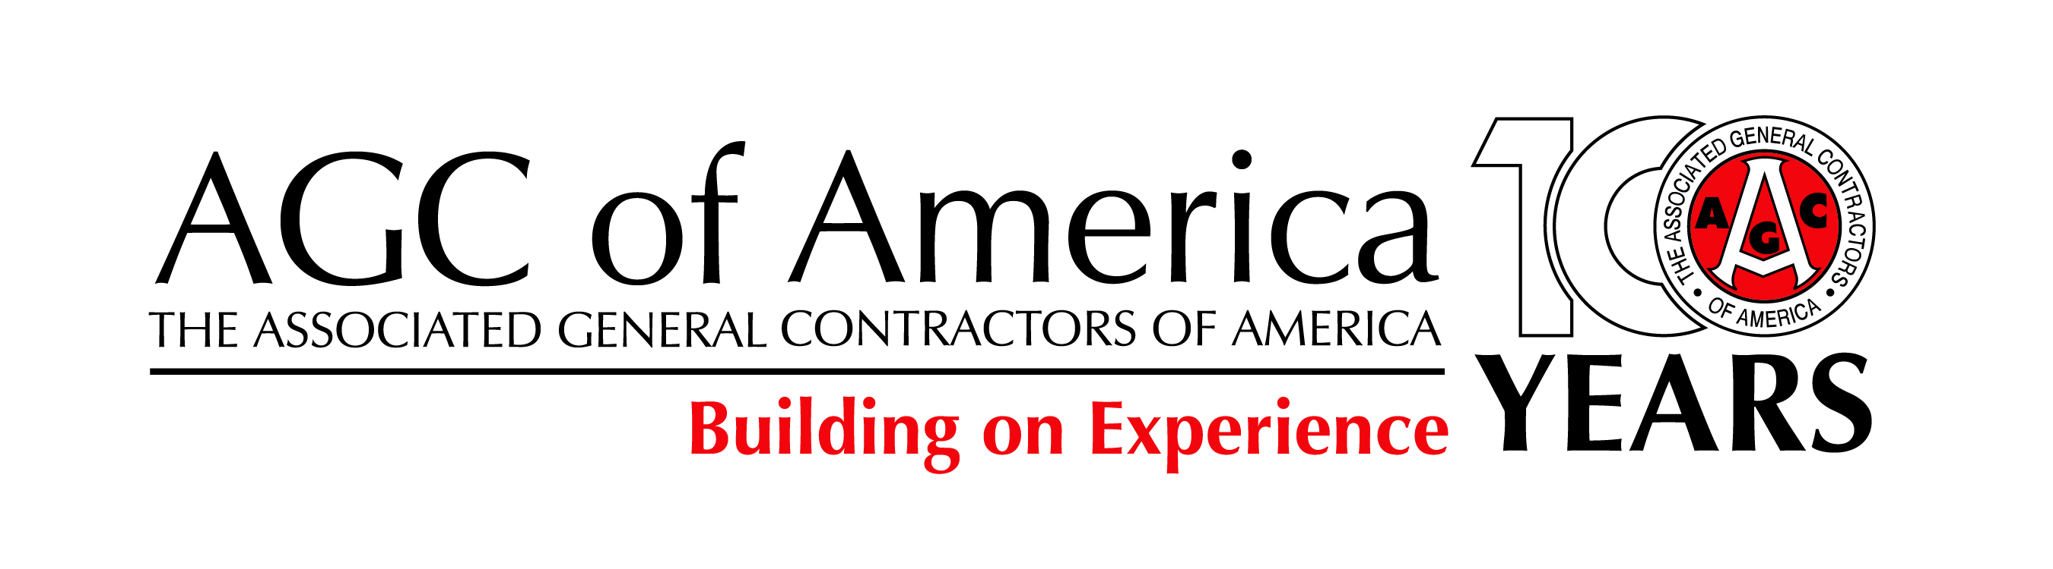

FOR IMMEDIATE RELEASE CONTACT: Brian Turmail
Monday, February 12, 2018 (703) 459-0238; turmailb@agc.org
PRESIDENT’S INFRASTRUCTURE PLAN SHOULD SERVE AS IMPETUS FOR LEGISLATION TO IMPROVE AGING AND OVER-BURDENED PUBLIC WORKS
Construction Official Urges Congress to Act Quickly to Pass New Infrastructure Legislation Now that the President Has Outlined an Ambitious Plan to Invest $200 Billion in New Federal Funds

The chief executive officer of the Associated General Contractors of America, Stephen E. Sandherr, released the following statement in reaction to the release today of President Trump’s proposal to improve and rebuild the country’s aging public works, including roads, bridges, airports, waterways and clean water systems:

“The President has outlined a needed and thought-provoking proposal to rebuild and improve the nation’s aging and over-burdened public infrastructure. The details of this proposal are important and many, including this association, will seek changes to further improve upon the President’s concept. Yet the most significant aspect of today’s release is that it signals the start of what should be a timely, bipartisan and bicameral process to identify the best ways to fund and finance desperately needed improvements to our public infrastructure.

“This process should build on the many positive aspects of the President’s infrastructure proposal. These include increasing direct federal funding for public works by at least $200 billion over the next ten years; making improvements to the federal permitting process that maintain strong environmental protections while significantly accelerating project reviews; and finding innovative new ways to use federal funds to leverage additional state, local and private-sector funding for infrastructure.

“At the same time, as the President’s own proposal makes clear, Congress must identify ways to address chronic funding shortfalls affecting the federal Highway Trust Fund that have put needed highway, bridge and transit improvements at risk too many times during the past decade. And Congress must also identify effective and long-term ways to fund other infrastructure improvements that are just as vital to our continued economic success as is the surface transportation program.

“Moving forward, this association will work vigorously to ensure Congress passes a significant, new, long-term infrastructure funding package as quickly as possible. Our goal will be to make sure every member of Congress appreciates that our economy will not be able to grow if we continue to allow our infrastructure to deteriorate.”

###

